**EE 2305 – Introduction to C Programming**

**Hardware Project 03**

**Digital VU Meter**

Project Features: Analog Input and Digital Output.

Program an Arduino board to accept an analog input voltage and display the magnitude of the voltage using a 10 LED display.

Input voltage = 0% of maximum (all LEDS off)

Input voltage = 30% of maximum

Input voltage = 70% of maximum

Document your program and include the following sections. Provide a brief description of the system and how you are designing it to operate.

**A. Hardware Diagram:**

Provide a hardware diagram of the components.

Analog Input

13

12

~ 11

~ 10

~ 9

8

7

~ 6

~ 5

4

~ 3

2

TX 1

RX 0

3.3V

5V

Gnd

Gnd

Vin

A0

A1

A2

A3

A4

A5

Power

Digital Input / Output

Arduino UNO

**B. Program Flowchart:**

Draw a flowchart of the program.

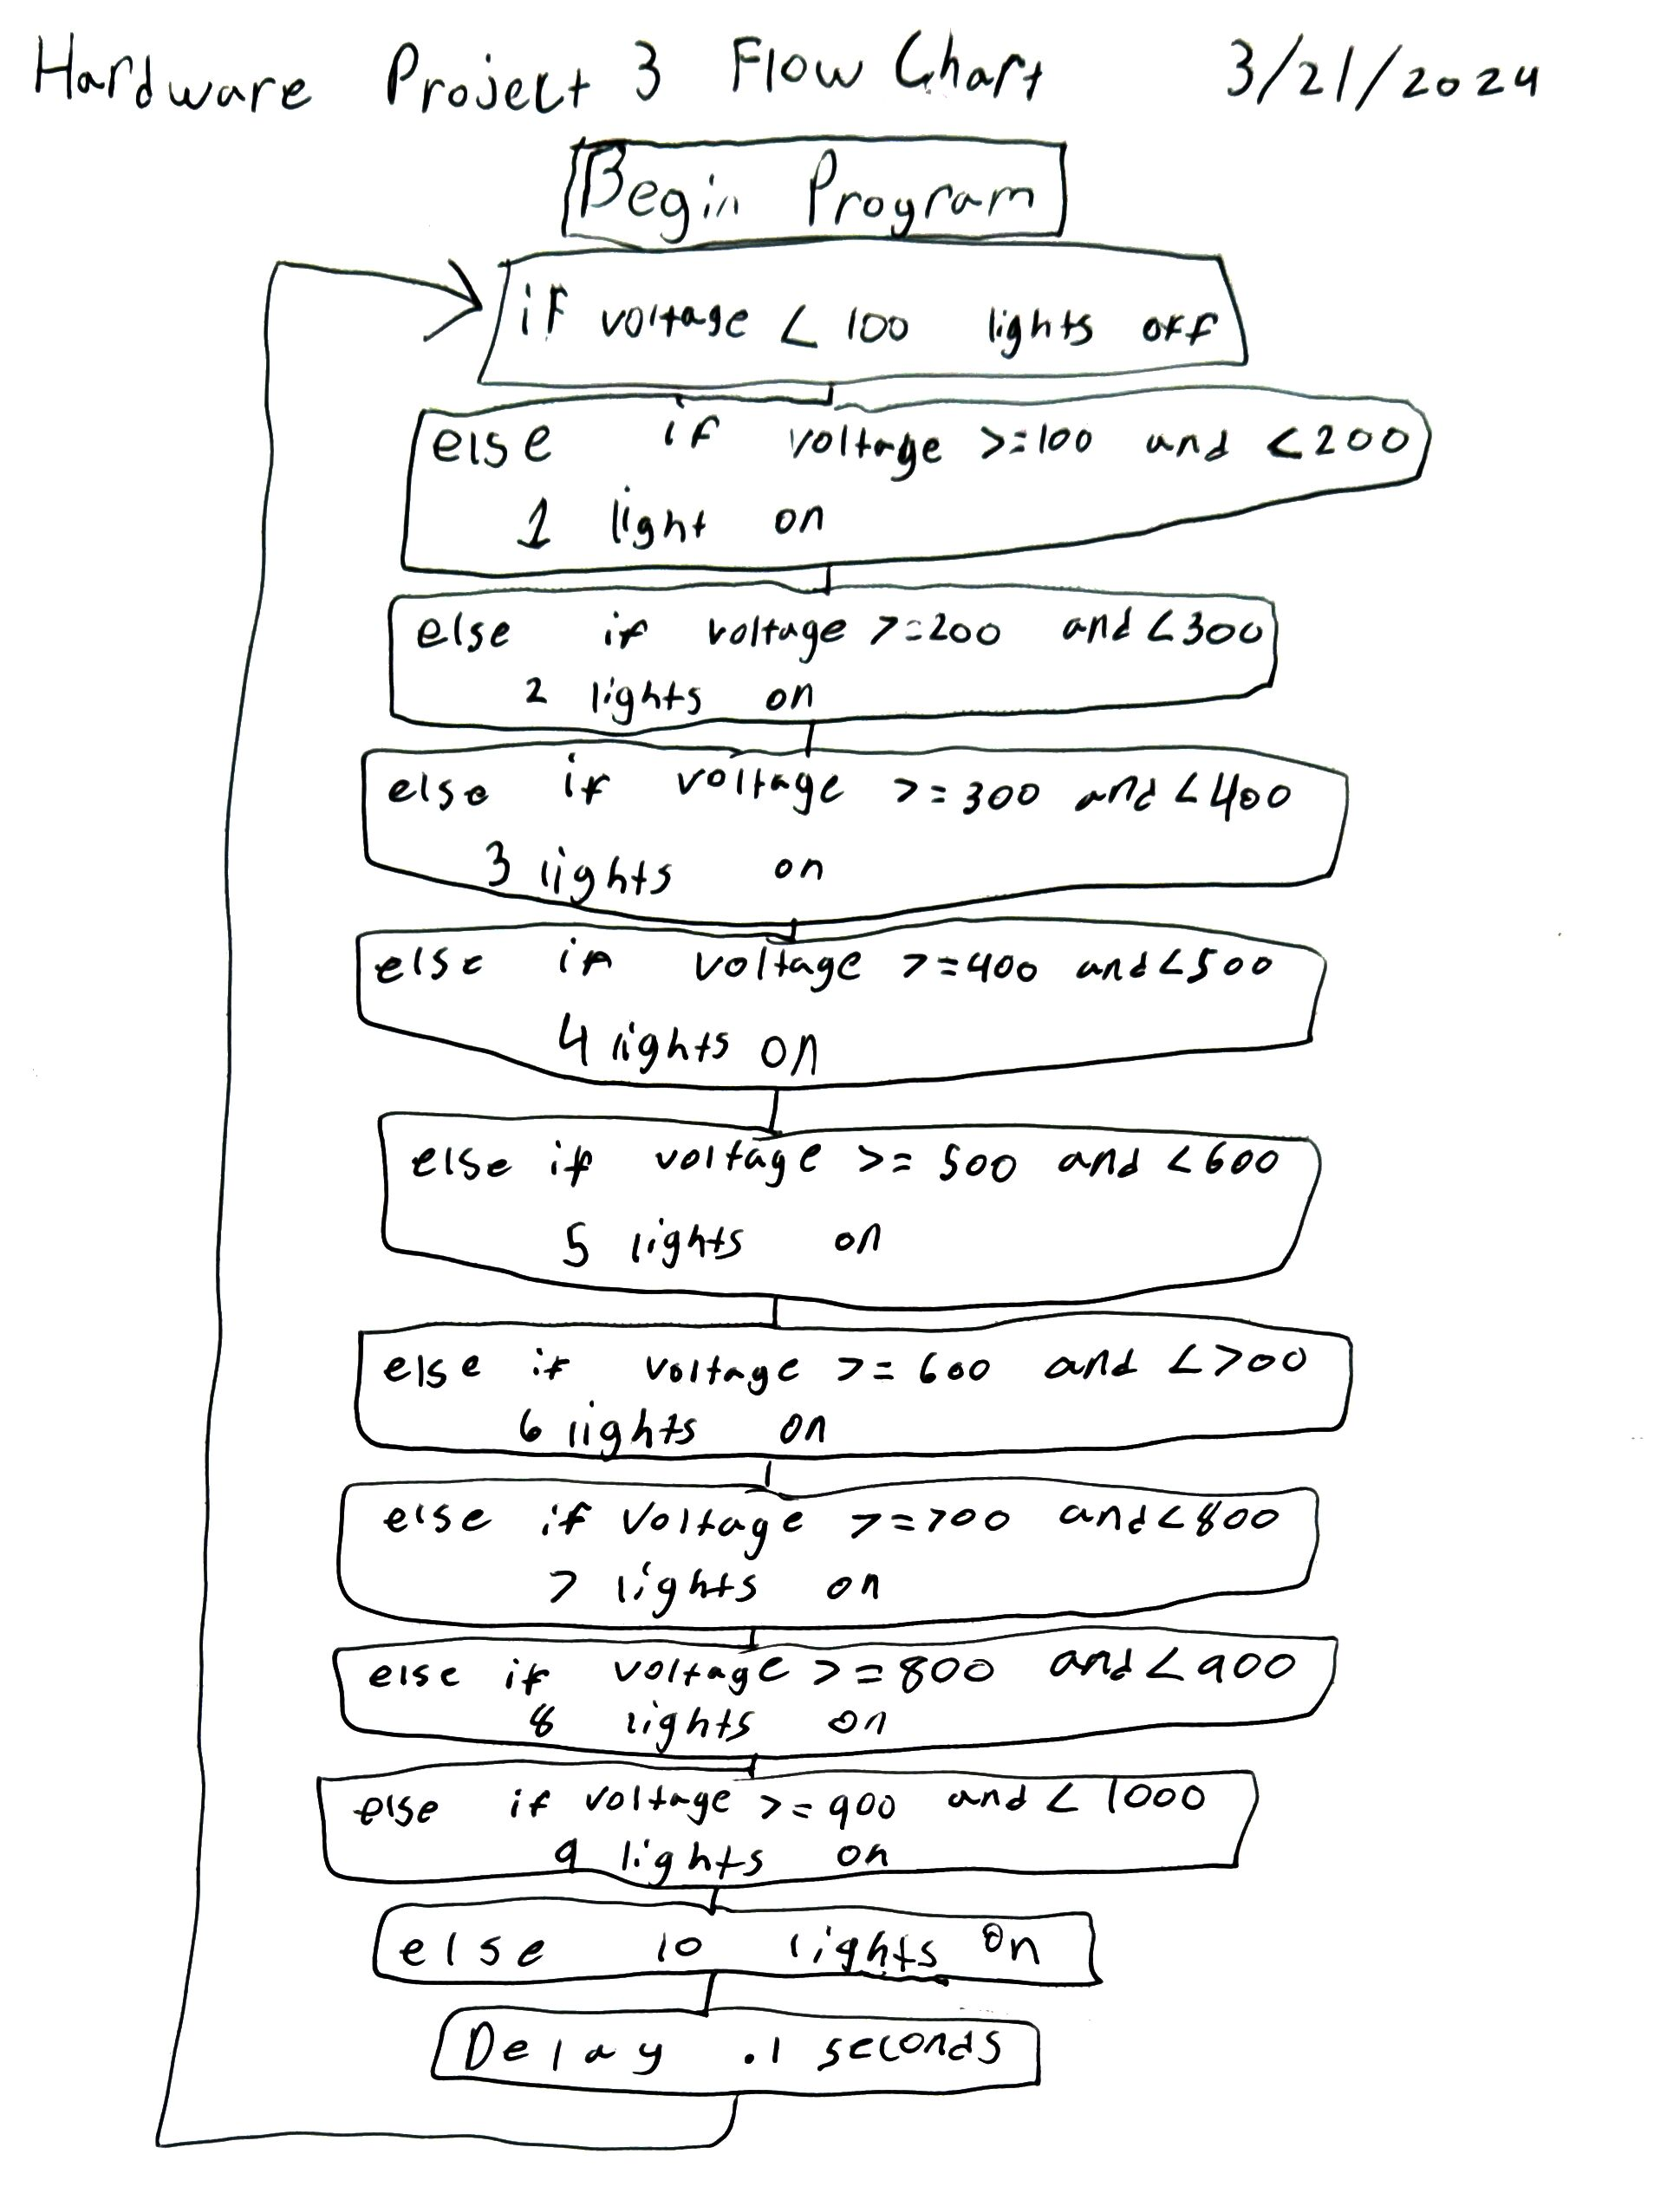

**C. Arduino Source Code**

Insert the Arduino Source Code into the document.

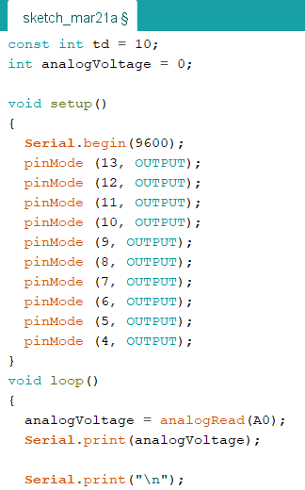

**D. Demonstration Video**

Record and upload a video demonstrating the operation of the circuit.

[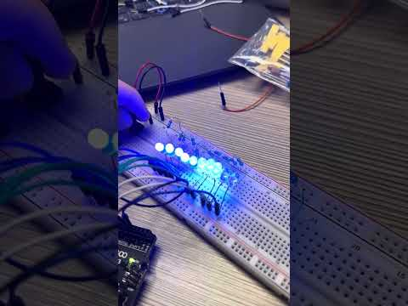](https://www.youtube.com/embed/ZR-R_TUOOs8?feature=oembed)

Save the document as a *PDF* file and submit the *PDF* document to *Blackboard*.